**EMBEDDED SYSTEM AND DESIGN**

**EXPERIMENT NO. 2**

**NUMBER SYSTEM EMULATOR**

Name: NAVARRO, ROD GERYK C.

Course/Section: CPE160P-4/A1

Group No.:

Date of Performance: 08/24/2024

Date of Submission: 08/25/2024

CYREL O. MANLISES, PH.D.

Instructor

**DISCUSSION**

In the first conversion experiment, I decided to create a binary to 2 s complement converter. The circuit was done easily by adding 4 switches to represent the binary digits and 8 LEDs to represent the binary digits inputs and 2’s complement output. The 4 LEDs on the right are the LEDs for the indicator of the pressed button for the inputs binary and the buttons on the left are the button for the 2’s complement output.

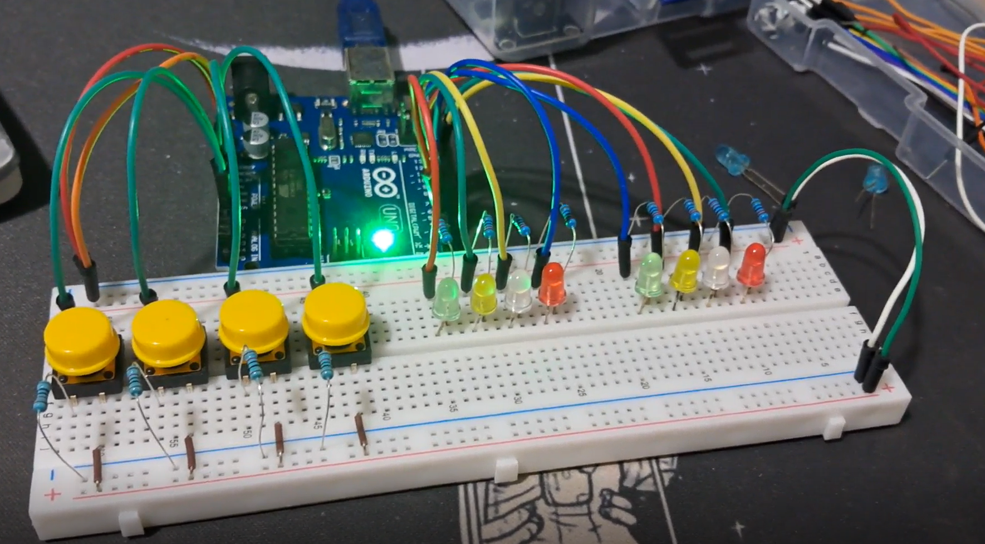

***Figure 1:*** *Connections of the circuit for the conversion of binary to 2’s complement.*

The coding of the 2 s complement converter, I decided to enter the code for the inputs that would require simultaneous button presses for the microcontroller to check for buttons pressed and then display the corresponding output in the other half of the LEDs. The code worked and the results were all correct.

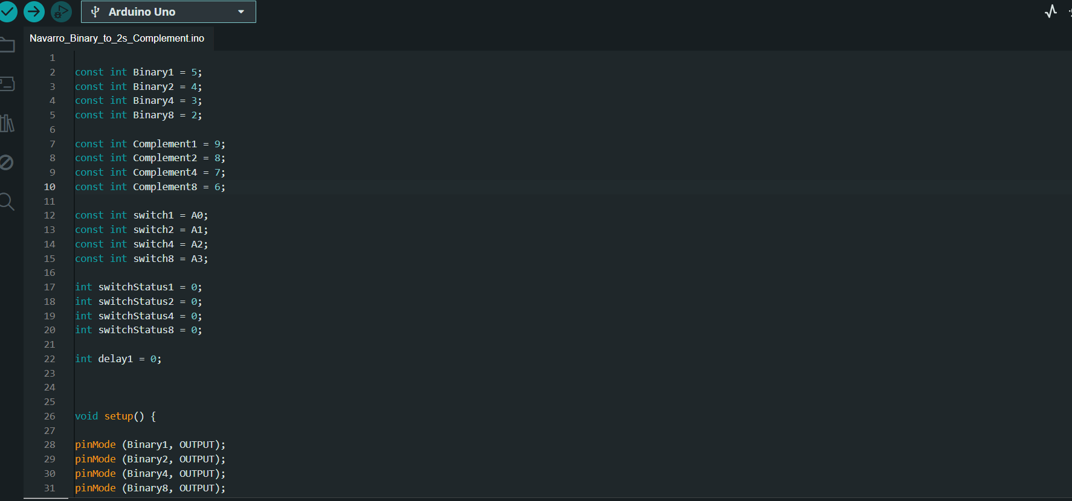

***Figure 2:*** *The code for the binary to 2’ complement conversion with checks for buttons pressed and converted output.*

For the second part of the experiment, I have created a conversion for 2421 code to BCD. This circuit is also similar in the first conversion. However, this conversion has its own different program compared to the first one. Same goes here for the conversion which involves the LEDs for the button pressed and the converted BCD output.

**

***Figure 3:*** *Connections of the circuit for the conversion of 2421 code to BCD.*

The coding of the 2421 converter to BCD, I also decided to enter the code for the inputs that would require simultaneous button presses for the microcontroller to check for buttons pressed and then display the corresponding output in the other half of the LEDs. The code worked and the results were all correct.

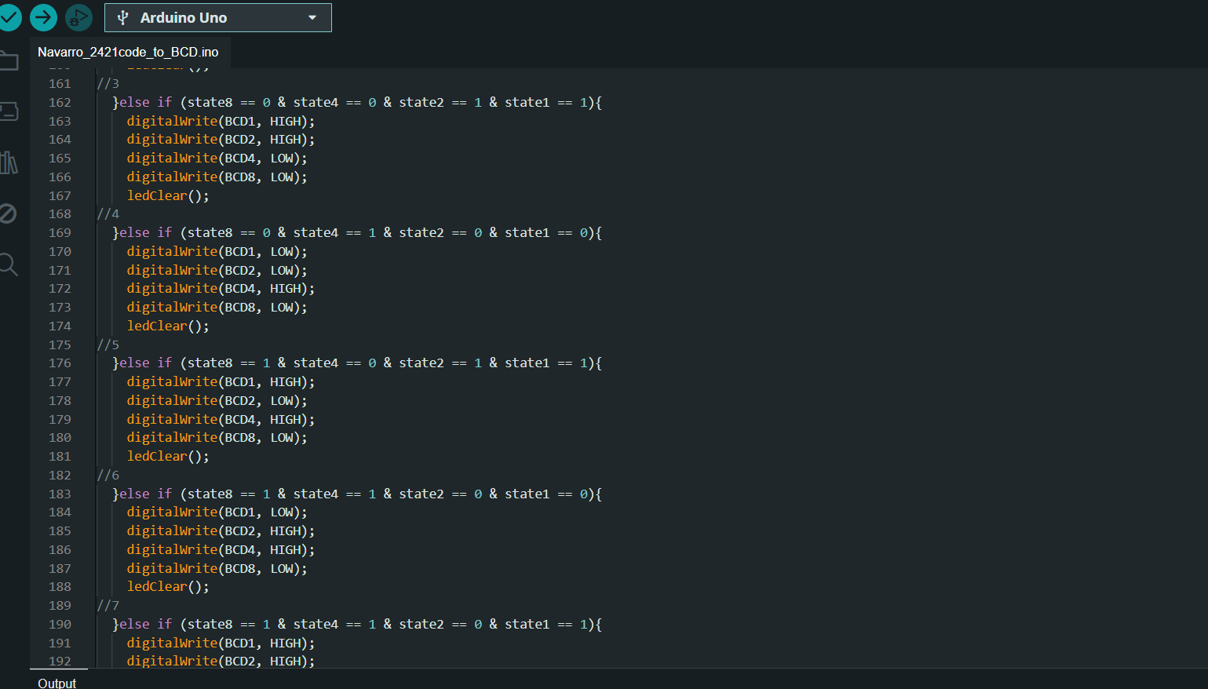

***Figure 4****: The code for 2421 code to BCD conversion with checks for buttons pressed and converted output.*

For the third part of the experiment, I used a seven-segment display to convert excess-3 binary to decimal. I used buttons and 4 LEDs for the inputs and the seven-segment LED display as output.

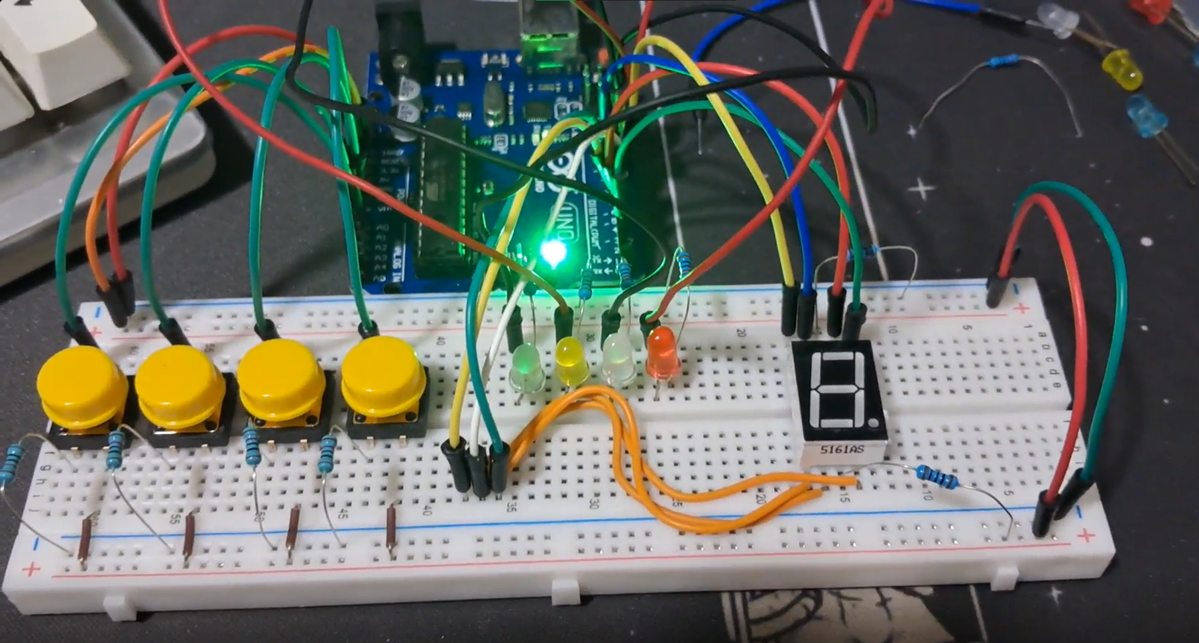

***Figure5****: Connections of the circuit for the excess-3 to decimal converter.*

In this code, it is the same as the first part of the experiment which I decided to enter the code for the inputs that would require simultaneous button presses for the microcontroller to check for buttons pressed and then display the corresponding output in the other half of the LEDs, and I coded for the microcontroller to check for simultaneous press first before moving on to the individual presses for the input.

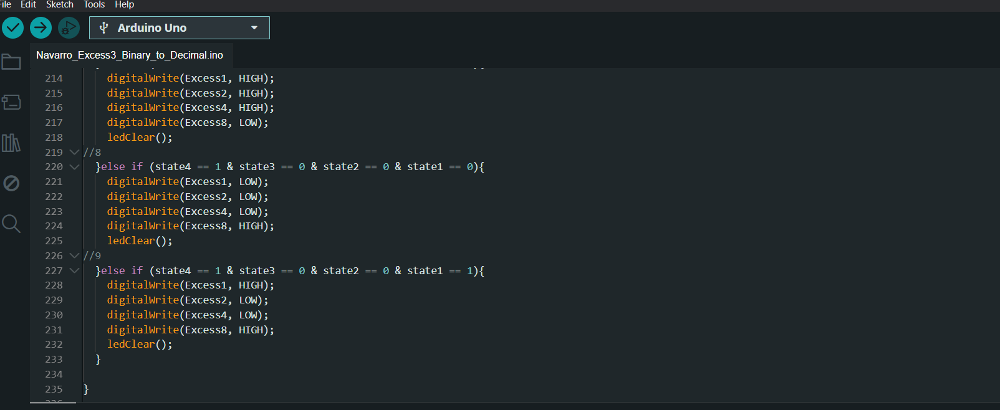

***Figure 6:*** *The code for excess-3 to decimal conversion with checks for buttons pressed and converted output using seven segment display.*

**CONCLUSION**

The experiment successfully demonstrated the process of converting different number systems using an embedded system. Through the construction of circuits and coding of a microcontroller, each part of the experiment binary to 2’s complement, 2421 code to BCD, and excess-3 to decimal was accomplished with accurate results. The use of LEDs and a seven-segment display effectively represented the inputs and outputs, making it easier to verify the correctness of the conversions.

This experiment not only reinforced our understanding of number system conversions but also highlighted the importance of precise coding and circuit design in embedded systems. By systematically checking for button presses and ensuring correct outputs, I was able to achieve the desired outcomes, which aligns with the objectives of this exercise.